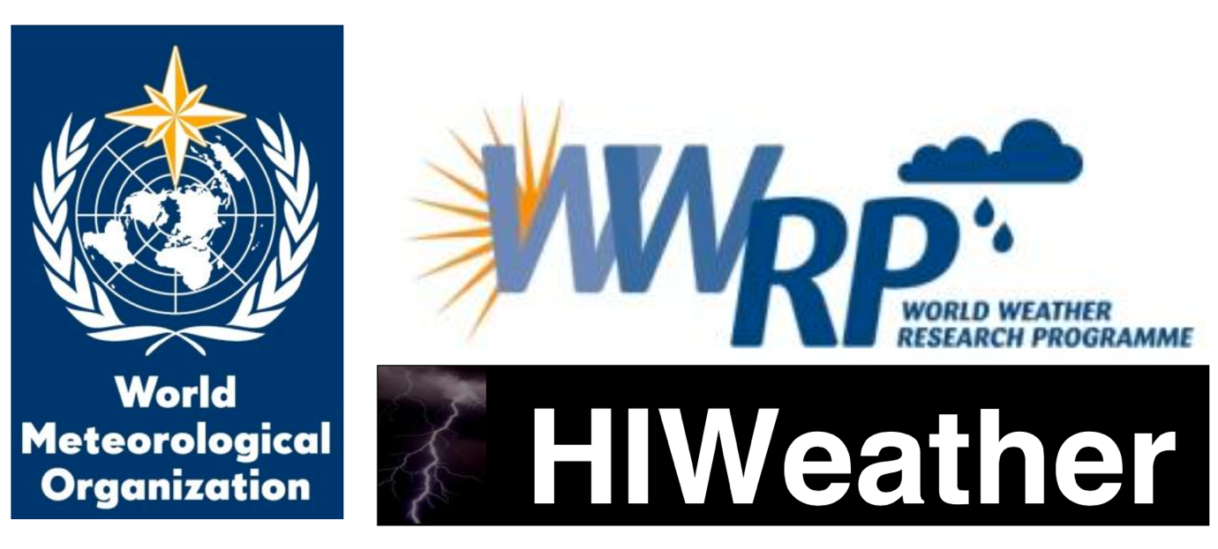

**HIWeather**

**Health impacts outline**

**Version: 7th August 2017**

**Introduction**

High Impact Weather (HIWeather), a research activity within the World Weather Research Programme (WWRP), aims to improve extreme weather event forecasting, both in spatial resolution and predictive lead time. A significant beneficiary of HIWeather products could be decision makers in emergency health care provision.

**Structure**